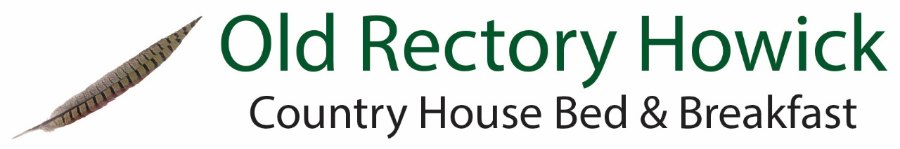

Wine List
Selected for us by local merchant, Michael Jobling Wines.
Our house wines are available by the glass, please use the measures provided.
White Wine | 175ml | 250ml | Bottle
Cuvee Jean Paul Gascogne Blanc de Blanc Secs, Pays des Cotes de Gascogne  A crisp, fresh dry white made with Columbard grapes. 2015/16 | £3.75 | £4.95 | £13.95
Allamanda Pinot Grigio, Italy  A light easy drinking Pinot Grigio with a hint of citrus |  |  | £14.95
Rolleston Vale Chardonnay, South Australia  A vibrant fresh white with peach and melon flavours and a hint of oak on the finish |  |  | £16.00
Makutu Sauvignon Blanc, Marlborough New Zealand  With ripe tropical and gooseberry flavours this Sauvignon Blanc from Selini Estates is great as an aperitif or with seafood. |  |  | £18.95
Rose Wine
Perchon Grenache Rose, WO Swartland, South Africa  Delicate floral hints and wild red fruit flavours finish with zesty grapefruit acidity | £3.95 | £5.20 | £15.95
Red Wine
Cuvee Jean Paul Vaucluse Rouge, Vin de Pays de Vaucluse  From the southern Rhone Valley, soft, fruity and drinkable | £3.75 | £4.95 | £13.95
Casa Santiago Pinot Noir, Central Valley, Chile  Aromas of cherry, strawberry and sweet spice with appealing freshness |  |  | £15.95
Kaleau Malbec, San Martin, Mendoza, Argentina  A soft, juicy wine packed with brambles and berries |  |  | £17.95
L’Enclos Merlot/Cabernet, Domaine de Castelnau, IGP Pays d’Oc  A deep red wine with red berries. Crushed strawberries and balsamic aromas finishing with notes of leather and spices |  |  | £21.95
Sparkling Wines & Champagnes |  | 200ml
Ponte de Rialto Prosecco NV 20cl Italy  Fun sized sparkling wine, great with Alnwick Gin Liqueur |  | £7.50
Henners Brut, East Sussex  A wonderful English Sparkling wine with a delicate white flower bouquet and hints of citrus, apple and oak. |  |  | £39.95

Northumbrian Beers and Real Ales
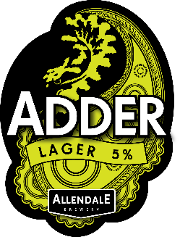 | Adder Lager  Allendale Brewery. Award-winning lager traditionally brewed in a Bohemian style with slow fermentation. 330ml 5% ABV  £4.20 | 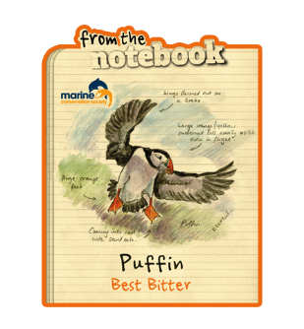 | Puffin Best Bitter  From the Notebook. Easy to drink beer with smooth flavour and firm bitter aftertaste  10p per bottle to Marine Conservation Trust. 500ml 3.8% ABV  £4.70
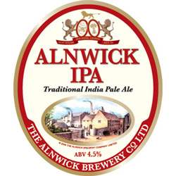 | Alnwick IPA (Gluten free)  Alnwick Brewery. A traditional India Pale Ale with a hoppy aroma of bitter orange. 500ml 4.5% ABV  £4.20 | 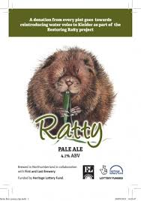 | Ratty Ale  First and Last Brewery. A session pale ale. Sales support Northumberland Wildlife Trust Water Vole project at Kielder Forest. 500ml 4.1% ABV  £4.20

Spirits and Liqueurs
Please use the measures on the bar. 25ml single and 50ml double. Prices below are for single 25ml measures. Ask us for ice and lemon or lime.
Alnwick Rum | £2.00 | The Alnwick Rum Company. Bold, spicy, dark rum based on a 90 year old local recipe. 43% ABV
Alnwick Gin | £2.50 | Alnwick Gin Co. Silver medal winning hand crafted gin. 37.5% ABV
Bombay Sapphire Gin | £2.00 | From the Laverstoke Mill Distillery in rural Hampshire 40% ABV
Grey Goose Vodka | £2.20 | Single origin French vodka 40% ABV
Glenfiddich 12 yo | £3.00 | Speyside single malt whisky 40% ABV
Glenmorangie 10 yo | £3.00 | Ross-shire single malt matured in bourbon oak casks 40% ABV
MVH Regimental Port | £1.50 | Fine Ruby Port from Douro Portugal 19.5% ABV
Lindisfarne Mead | £2.00 | St Aidan’s Winery, Holy Island. Unique fortified honey wine made to a centuries old recipe
Alnwick Gin Liqueur | £1.50 | Rhubarb & Strawberry, Lime & Ginger or Raspberry & Vanilla. Refreshing with natural fruit flavourings. 20% ABV

Soft drinks and Mixers
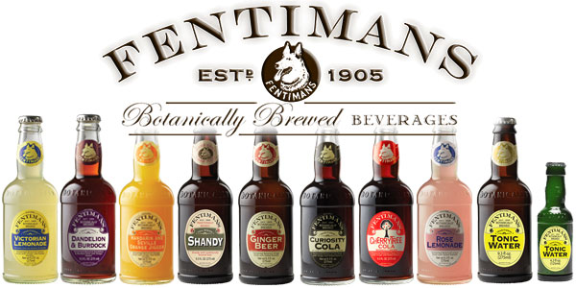 | Fentiman’s have been brewing natural botanical drinks in Northumberland for over 100 years.

Curiosity Cola, Ginger Beer or Victorian Lemonade 275ml | £1.95
Tonic Water, Light tonic Water or Pink Grapefruit Tonic 125ml | £1.00

Drink suggestions
Some of our favourite combinations!
Dark & Stormy | 50ml Alnwick Rum, Fentiman’s Ginger Beer | £5.95
Alnwick G&T | 25ml Alnwick Gin, Fentiman’s Pink Grapefruit tonic | £3.50
Vodka & Coke | 25ml Grey Goose Vodka, top up with Fentiman’s Curiosity Cola | £4.15
Rhubarb Fizz | 25ml Alnwick Gin Rhubarb & Strawberry Liqueur, Ponte de Rialto Prosecco | £9.00
Ginger Martini | 50ml Alnwick Gin Ginger & Lime Liqueur, 25ml Grey Goose Vodka, a squeeze of lime | £5.20
Old Rectory Raspberry | 25ml Alnwick Gin Raspberry & Vanilla Liqueur, 25ml Grey Goose Vodka, Fentiman’s Victorian Lemonade, Lime wedge | £5.65

